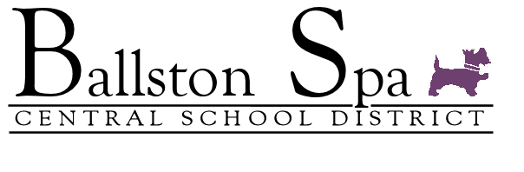

**Updates from the District Office**

January 8, 2021

Dear BSCSD Parents and Caregivers:

As promised in our January 5 Updates, I wanted to update you on our January 11 status. Despite our best collective efforts to get back to our regular hybrid model, based on the increasing number of positive cases and mandatory quarantine requiring substantially more tracing and our decreasing ability to provide consistent staffing in all areas, I regret to announce that **we will be moving to a fully remote model for all grades next week, January 11 – January 15, 2021**.

There are a few exceptions to this in the following areas:

1. PTech – Our senior PTech students will still attend their Clean Tech ECHS program at the HVCC Malta Campus.
2. BOCES CTE – Students will still attend their program and will be on a Friday transportation schedule.
3. Out-of-District Placements – Students will continue to be transported.

For elementary students, principals will be communicating with parents shortly regarding materials pick up early next week.

I fully understand the challenges that this model presents to families, particularly those who struggle to find child care, but in the current environment I simply cannot see how we can maintain the health and safety of students and staff while providing consistency of instruction that we need.

A continued reminder to parents and caregivers to utilize our [COVIDreport@bscsd.org](mailto:COVIDreport@bscsd.org) mailbox to report cases and quarantining to us.

I will update you by or before Friday, January 15 regarding our plans for reopening on Tuesday, January 19 (the district is closed on Monday, January 18 for the Observance of Martin Luther King, Jr.).

Finally, please continue to [stay vigilant](https://www.bscsd.org/site/default.aspx?PageType=3&DomainID=8&ModuleInstanceID=21830&ViewID=6446EE88-D30C-497E-9316-3F8874B3E108&RenderLoc=0&FlexDataID=44874&PageID=9)in mask wearing, social distancing, avoiding large crowds, completing all portions of the Pinpoint screener each day including temperature checks, and practicing hand and mouth hygiene as these are the critical steps that will keep us all healthy thereby allowing our schools toopen on January 19.

Thanks very much.

Ken Slentz

Superintendent of Schools

Ballston Spa CSD